End of Year Progress Report

While the initial attempt to fabricate nanocomposite scintillators by suspending CdS nanoplatelets in epoxy resin was largely unsuccessful, it provided valuable information as to what the next steps should be. The biggest limiting factor was the high self-absorption of any scintillation due to nanoparticle aggregation, so this is a key factor to mitigate in the next attempt. After extensively reviewing the literature on the subject, we have concluded that our best course of action to achieve this is to first partially exchange the nanoparticle surface ligands with a coupling agent compatible with the pixel matrix. To this end, we have decided to rather use styrene as our monomer for the matrix instead of epoxy resin, and introduce BMEP (Bis[2-(methacryloyloxy)ethyl] phosphate) as a bifunctional ligand that acts as a coupling agent to evenly disperse nanoparticles and mitigate aggregation. Additionally, we have decided to incorporate more traditional scintillator agents PPO (2,5-Diphenyloxazole) and POPOP (1,4-bis-2-(5-phenyloxazolyl)-benzene) into the matrix. The aim is to start with a proven functional scintillator, and use the nanoparticles to improve its performance, instead of attempting to circumvent traditional techniques by only relying on nanoparticles for scintillation.
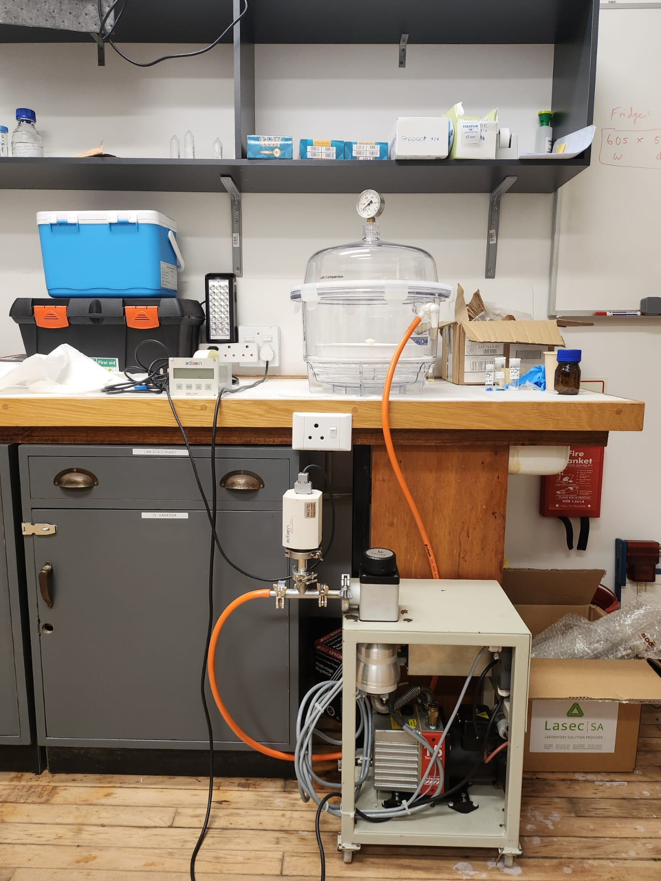
Current laboratory setup for the production of polystyrene scintillator pixels at UCT.
Thus far, we have established the laboratory setup at UCT for the production of polystyrene materials. The equipment currently in place includes a fume hood, a controlled condenser environment, a pump system, and a heating unit in Figure 2. We are presently in the proof-of-concept stage. This setup will be used to synthesize the polymer and produce scintillator pixels. This arrangement does not include a furnace, but it will be used to also prepare the prepolymer, which will then be poured into the new mold design (described below) to produce bulk pixels.

This approach differs from the current single pixel silicon molds, which allow only 1 pixel production at a time.We are currently awaiting the arrival of additional chemicals needed to proceed with the proof-of-concept work for producing scintillators at UCT.
Chemicals purchased:
- Styrene (matrix)
- PPO (primary solute)
- POPOP (wavelength shifter)
- BMEP (coupling agent)
- BPO (radical initiator) - Still pending

Figure 1: Current laboratory setup for the production of polystyrene scintillator pixel

Design of a Mold for Thermally Activated Polymerization in an Electric Furnace

Given the various methods available for polymerization—one of which involves using a furnace for bulk polymerization—I am currently designing a mold that will enable the production of multiple variations of pixels in a single batch, unlike the silicon mold we currently have. This new mold will allow a bulk cast to be fabricated and later cut into individual pixels. The design is partially complete and includes the bill of materials listed below. Fabrication will take place at UCT, and the materials still need to be purchased.
- The mold has two flat glass plates supported by an aluminum frame.
- Steel spring clamps will be used to hold the entire assembly firmly in place during the polymerization process.
- The aluminum frame includes two threaded openings:
  - One opening for pouring the prepolymer into the mold.
  - A second opening to allow air to escape during filling.
- Teflon tape gaskets are placed between the glass plates and aluminum frame to prevent leakage.

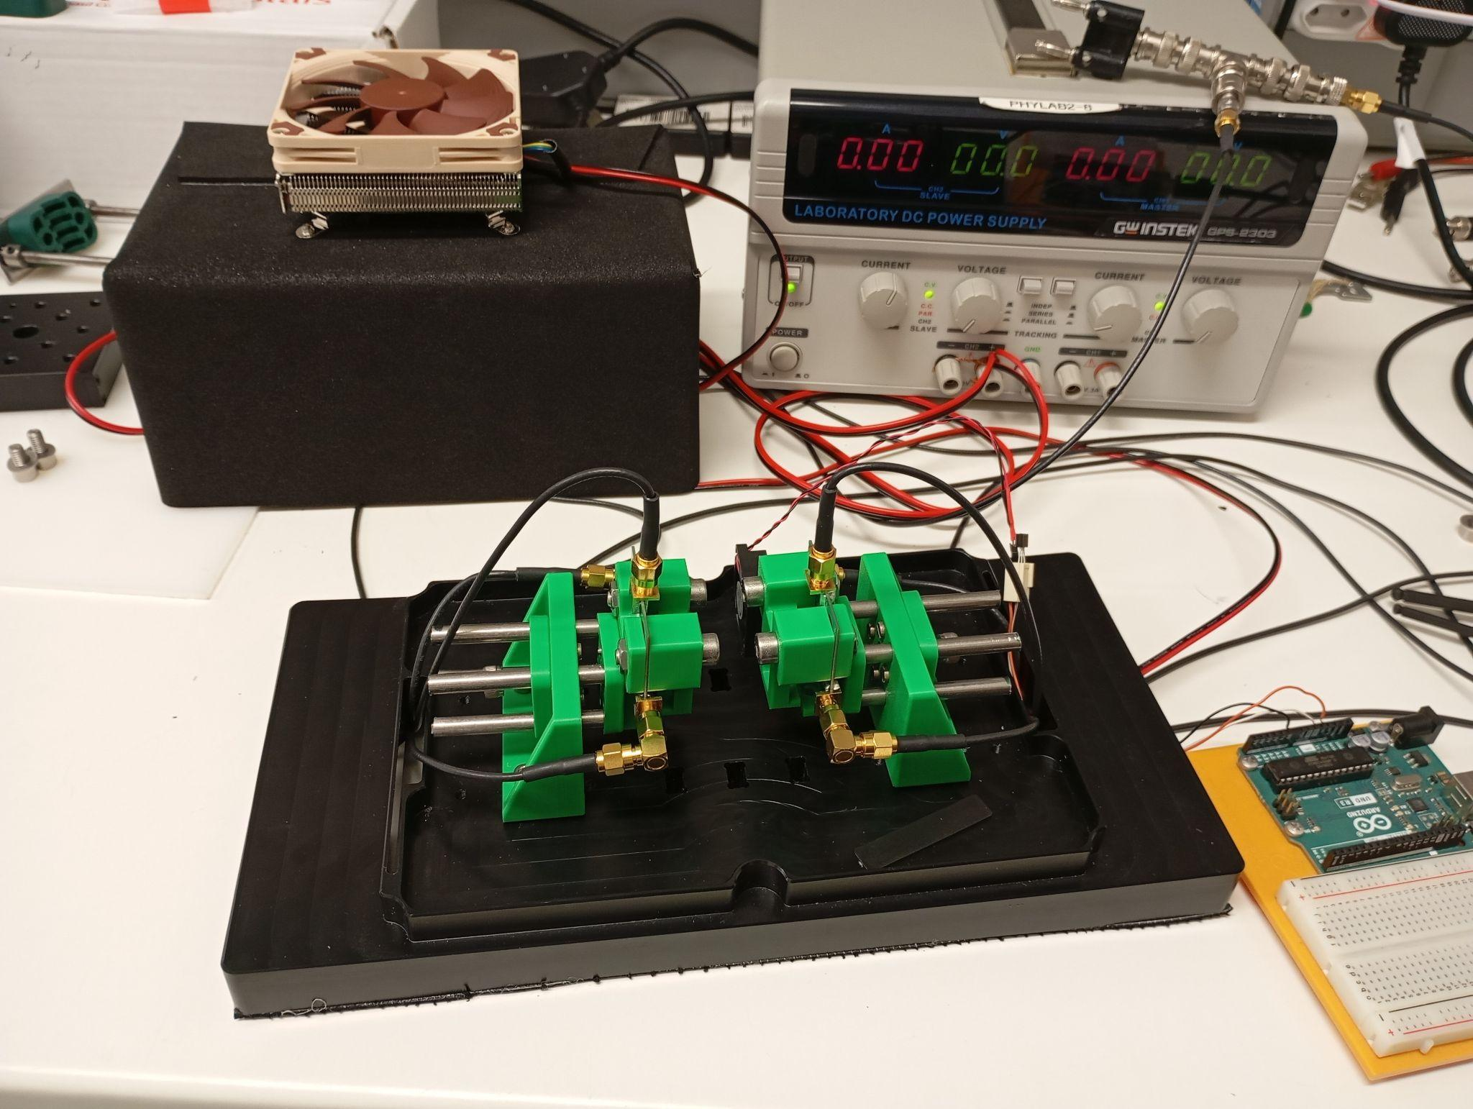
Improvements to CTR test bench

In preparation for the new batch of potential nanocomposite scintillators, the CTR bench has been upgraded with the following additions. The setup has been redesigned to improve alignment and is now housed inside a smaller, light-sealed darkbox. A fan-assisted peltier module in conjunction with new thermometry controls the ambient temperature inside the darkbox, mitigating SiPM response drift over time. Pixel clamps were added to improve coupling between scintillators and SiPMs, improving the signal-to-noise ratio.

Figure 2: The improved CTR Test Bench

